Kubernetes Task 2

- Create a Simple Pod Using YAML Task: Write a YAML file to create a Pod named firstpod with an nginx container. Verify the Pod creation using kubectl get pods and check the logs of the container using kubectl logs firstpod.
- Set Environment Variables in a Pod Task: Modify the YAML file to include environment variables myname: sabair and City: Hyderabad. Deploy the Pod and use kubectl exec <pod_name> -- env to check if the environment variables are set properly.
- Deploy a Pod with Commands (Args) in YAML Task: Modify the YAML file to add args that instruct the container to sleep for 50 seconds. Deploy the Pod and use kubectl describe pod to verify the args are correctly passed to the container.
- Create a Pod with Two Containers Task: Create a YAML file to define a Pod with two nginx containers inside. Use kubectl exec to access both containers and verify that both containers can communicate through the same network (e.g., using telnet between them).
- Set Up an Init Container in a Pod Task: Modify the YAML to include an init container that sleeps for 30 seconds before the main containers start. Verify the init container's execution using kubectl describe pod and check the logs to confirm its completion.
- Run a Dry Run Command to Generate YAML Task: Use the kubectl run nginx --image=nginx --dry-run=client -o yaml command to generate a Pod YAML definition. Modify the generated YAML to suit specific requirements (e.g., labels or environment variables) and deploy it.
- Use kubectl apply vs kubectl create Task: Create a YAML file to define a Pod. First, deploy it using kubectl create -f <file_name>.yml and then modify the YAML (e.g., change the image version). Use kubectl apply to redeploy and verify the difference between both commands.
- Edit an Existing Pod Configuration Task: Use kubectl edit pod <pod_name> to modify the running Pod's environment variables or image. After making the changes, verify if they took effect by checking the container logs or environment variables using kubectl exec.
- Expose a Pod Using a Service Task: Create a YAML file to expose your firstpod using a Service (ClusterIP). Ensure that your service is exposing the Pod on port 80 and verify it using kubectl get svc.
- Pod with Resource Limits and Requests Task: Add resource requests and limits to the containers in your YAML file. Specify CPU and memory requests/limits for both containers and deploy the Pod. Use kubectl describe pod to verify if the resource configurations are correctly applied.
- Step 1 — On Master
- Create the YAML file:
- nano firstpod.yml

- Paste this complete YAML:
- apiVersion: v1
- kind: Pod
- metadata:
- name: firstpod
- spec:
- containers:
- - name: nginx
- image: nginx

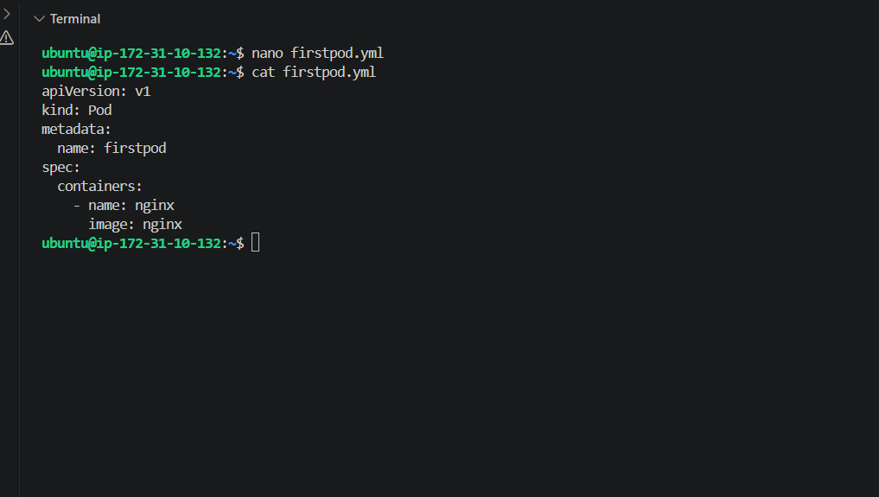
Step 2 — Create the Pod
kubectl apply -f firstpod.yml
Expected:
pod/firstpod created
Step 3 — Verify
kubectl get pods
Expected:
NAME READY STATUS RESTARTS AGE
firstpod 1/1 Running 0 ...
Step 4 — Check logs
kubectl logs firstpod
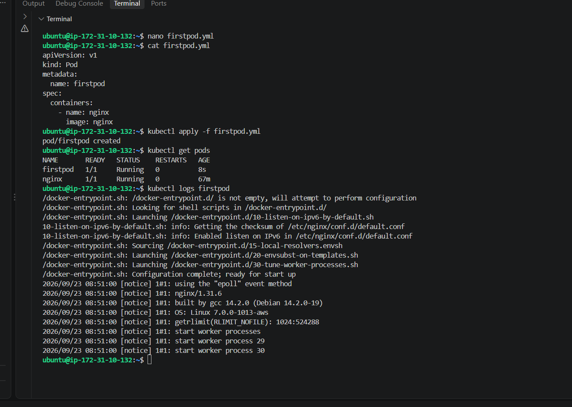
Task 2 — Environment Variables
Now we'll modify firstpod.yml to add:
- myname = sabair
- City = Hyderabad
1. Replace firstpod.yml
Run:
nano firstpod.yml
Replace the entire file with:
apiVersion: v1
kind: Pod
metadata:
name: firstpod
spec:
containers:
- name: nginx
image: nginx
env:
- name: myname
value: "sabair"
- name: City
value: "Hyderabad"
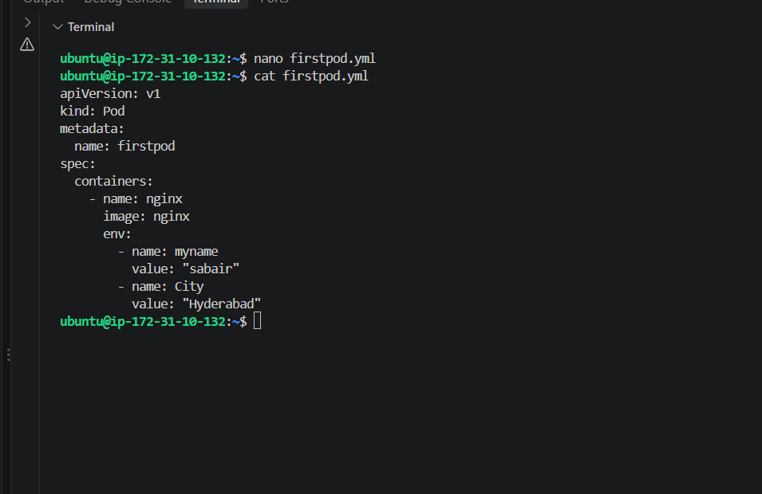
2. Important: Delete the old Pod
Because we're changing the Pod specification, delete the existing Pod first:
kubectl delete pod firstpod
3. Create the updated Pod
kubectl apply -f firstpod.yml
4. Check Pod
kubectl get pods
Wait until:
firstpod 1/1 Running
5. Verify environment variables
Run:
kubectl exec firstpod -- env | grep -E 'myname|City'
Expected:
myname=sabair
City=Hyderabad
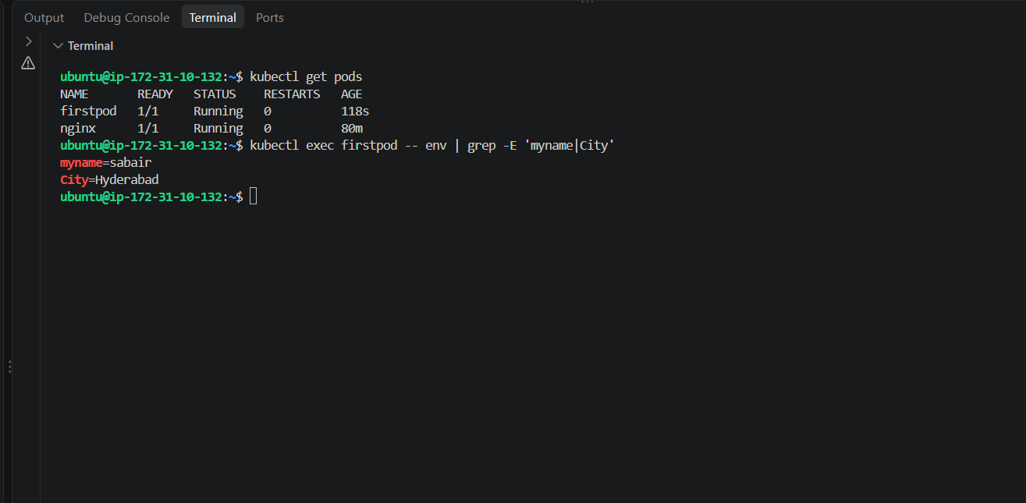
Task 3 — Pod with Commands / Args
Requirement: Modify the YAML so the container sleeps for 50 seconds, then deploy it and verify the args using kubectl describe pod.
We'll replace the YAML with a simple version.
1. Replace firstpod.yml
nano firstpod.yml
Use this complete file:
apiVersion: v1
kind: Pod
metadata:
name: firstpod
spec:
containers:
- name: nginx
image: nginx
args:
- /bin/sh
- -c
- sleep 50
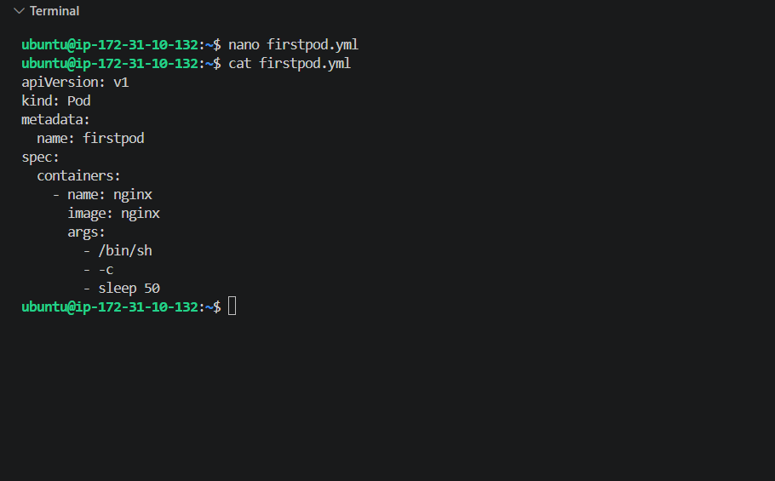
2. Delete the existing Pod
kubectl delete pod firstpod
3. Create the new Pod
kubectl apply -f firstpod.yml
4. Check the Pod
kubectl get pod firstpod
Because the container sleeps for only 50 seconds, you may see it transition quickly. That's expected.
5. Verify the args
Run:
kubectl describe pod firstpod
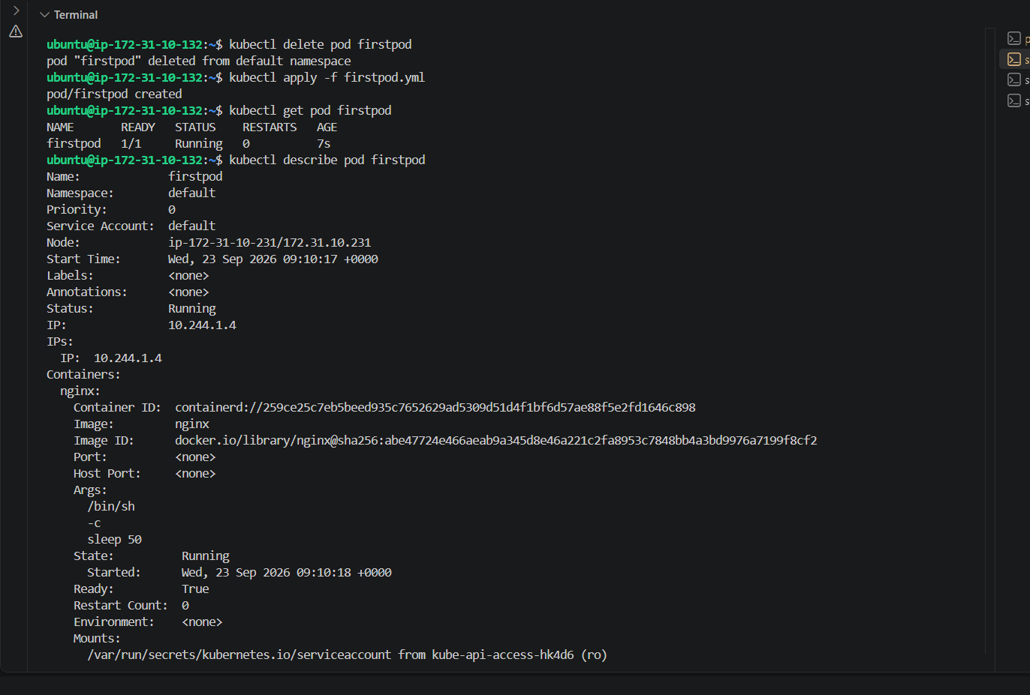
Task 4 — Pod with Two Containers
Requirement:
- One Pod
- Two nginx containers
- Access both using kubectl exec
- Verify they can communicate through the same network
1. Replace firstpod.yml
apiVersion: v1
kind: Pod
metadata:
name: firstpod
spec:
containers:
- name: nginx1
image: nginx

- name: nginx2
image: nginx
command: ["/bin/sh"]
args:
- -c
- |
sed -i 's/listen 80;/listen 8080;/' /etc/nginx/conf.d/default.conf
nginx -g 'daemon off;'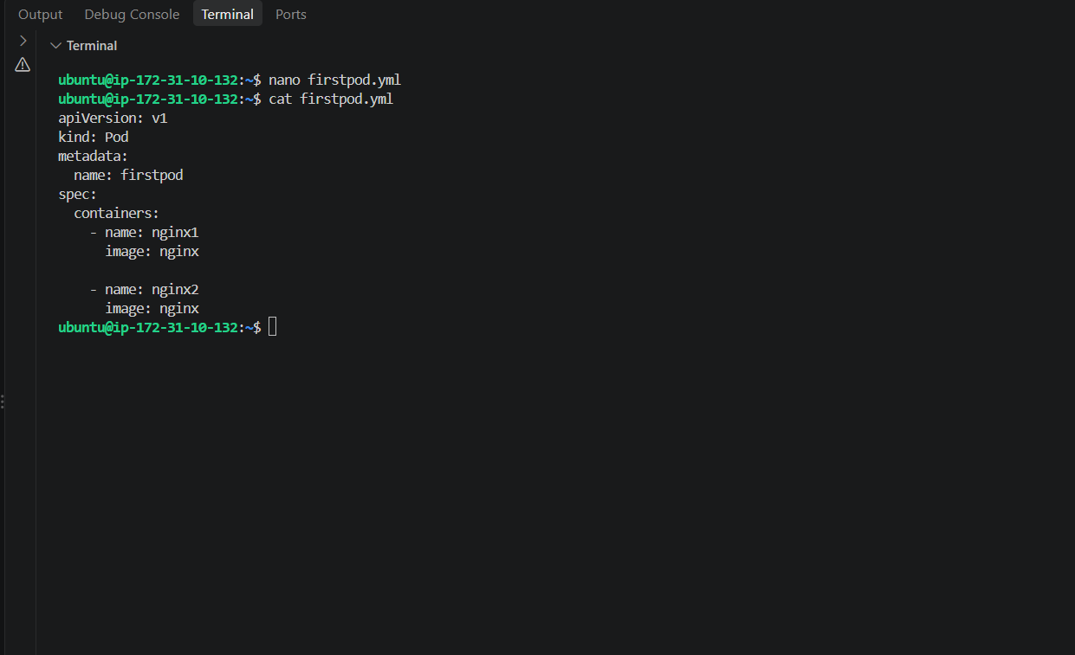
2. Delete the previous Pod
kubectl delete pod firstpod
3. Create the two-container Pod
kubectl apply -f firstpod.yml
4. Verify both containers
kubectl get pod firstpod
Expected:
NAME READY STATUS RESTARTS AGE
firstpod 2/2 Running 0 ...
5. Check both containers
First container:
kubectl exec firstpod -c nginx1 -- hostname
Second container:
kubectl exec firstpod -c nginx2 – hostname
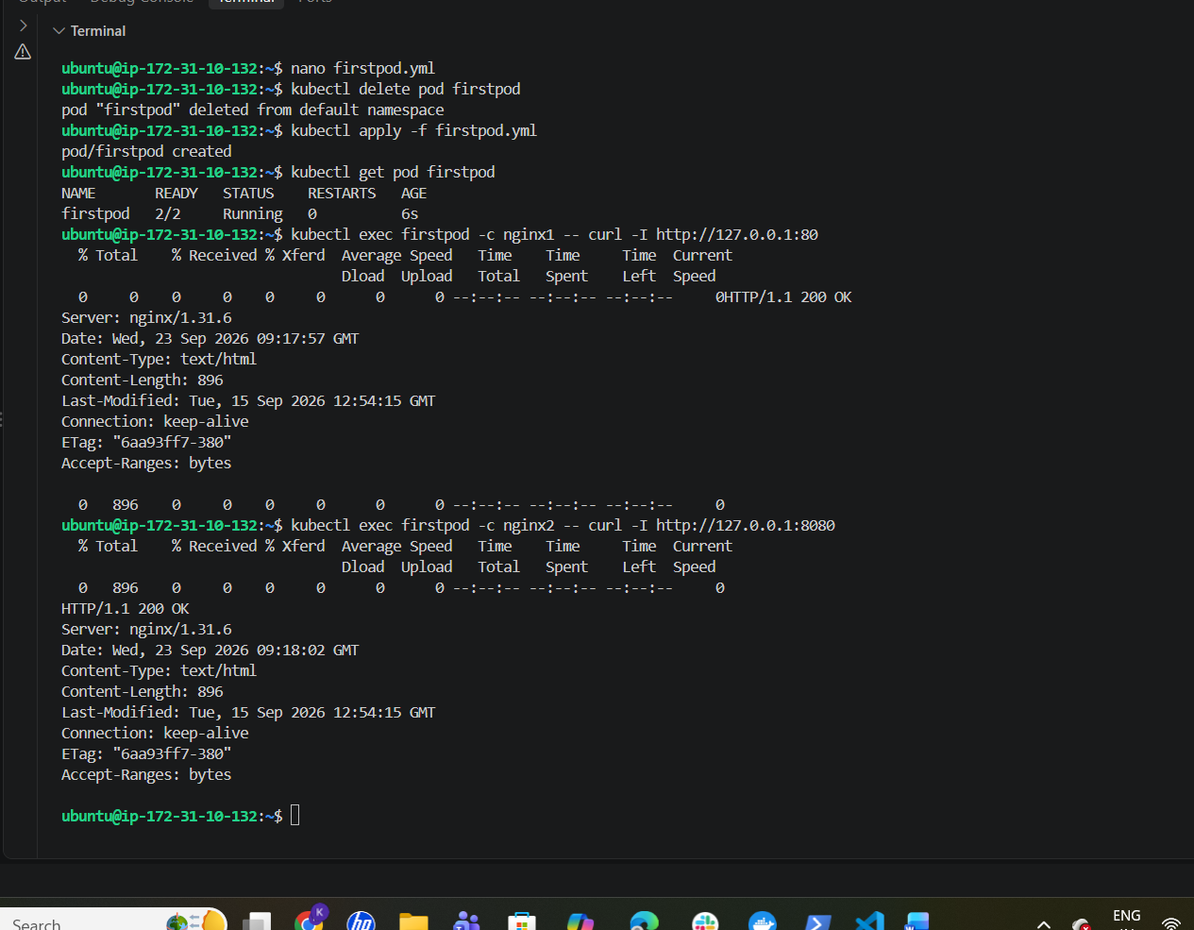
Task 5 — Init Container
Requirement:
- Add an init container
- Init container sleeps for 30 seconds
- Main containers start after init container completes
- Verify using kubectl describe
- Check init-container logs
We'll keep the two nginx containers and add the init container.
1. Replace firstpod.yml
nano firstpod.yml
Use this complete YAML:
apiVersion: v1
kind: Pod
metadata:
name: firstpod
spec:
initContainers:
- name: init-container
image: busybox
command:
- sh
- -c
- "echo Init container started; sleep 30; echo Init container completed"

containers:
- name: nginx1
image: nginx

- name: nginx2
image: nginx
command:
- /bin/sh
args:
- -c
- |
sed -i 's/listen 80;/listen 8080;/' /etc/nginx/conf.d/default.conf
nginx -g 'daemon off;'
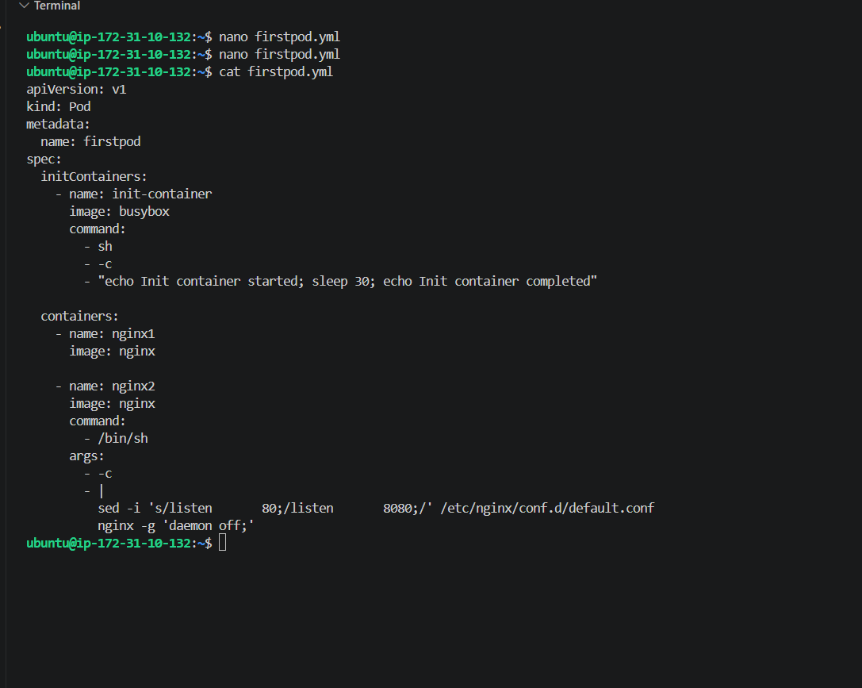
2. Delete old Pod
kubectl delete pod firstpod
3. Create new Pod
kubectl apply -f firstpod.yml
4. Immediately check
kubectl get pod firstpod
During the first ~30 seconds, you should see something like:
firstpod 0/2 Init:0/1
After 30 seconds:
firstpod 2/2 Running
5. Check Init Container logs
kubectl logs firstpod -c init-container
Expected:
Init container started
Init container completed
6. Verify with describe
kubectl describe pod firstpod
Look for:
Init Containers:
init-container:
Image: busybox
State: Terminated
Reason: Completed
And under containers:
Containers:
nginx1:
nginx2:
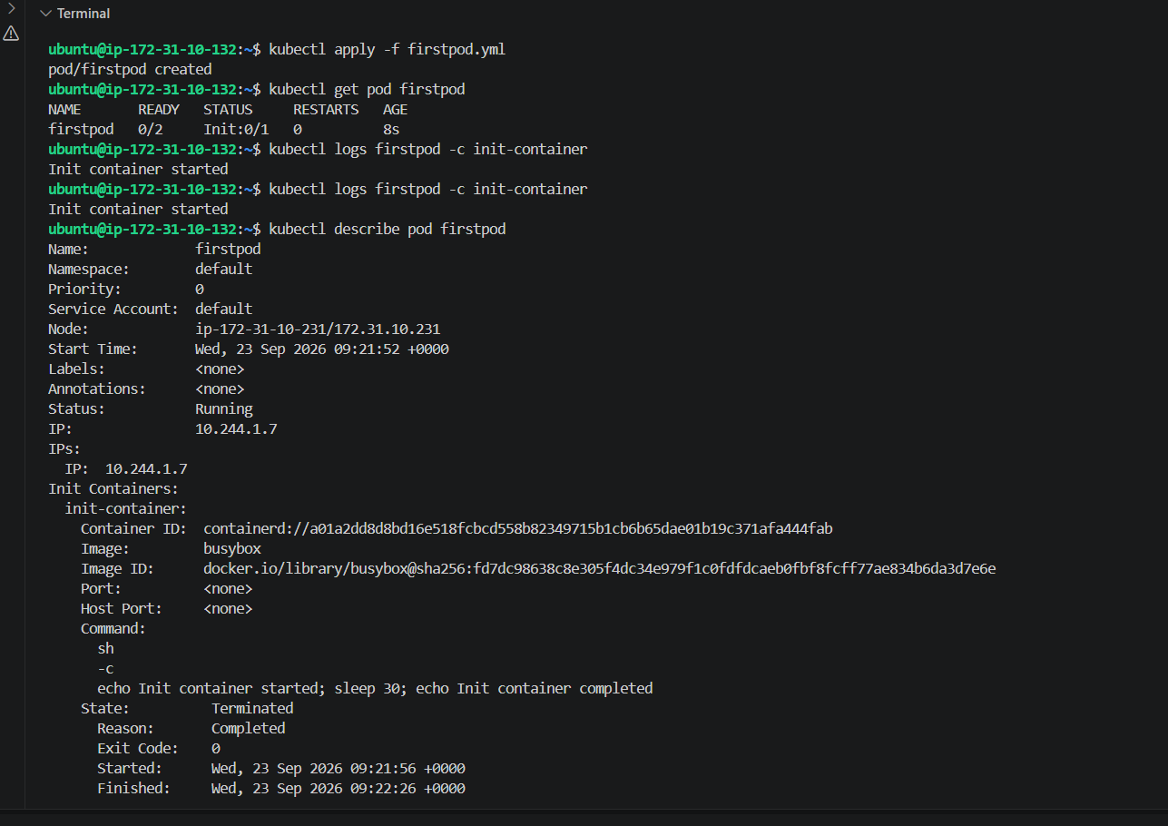
Task 6 — Generate YAML using Dry Run
Now we'll use:
kubectl run nginx --image=nginx --dry-run=client -o yaml
1. Generate YAML
Run:
kubectl run nginx --image=nginx --dry-run=client -o yaml > nginx-dryrun.yml
Check the generated file:
cat nginx-dryrun.yml
You'll get something similar to:
apiVersion: v1
kind: Pod
metadata:
name: nginx
spec:
containers:
- image: nginx
name: nginx
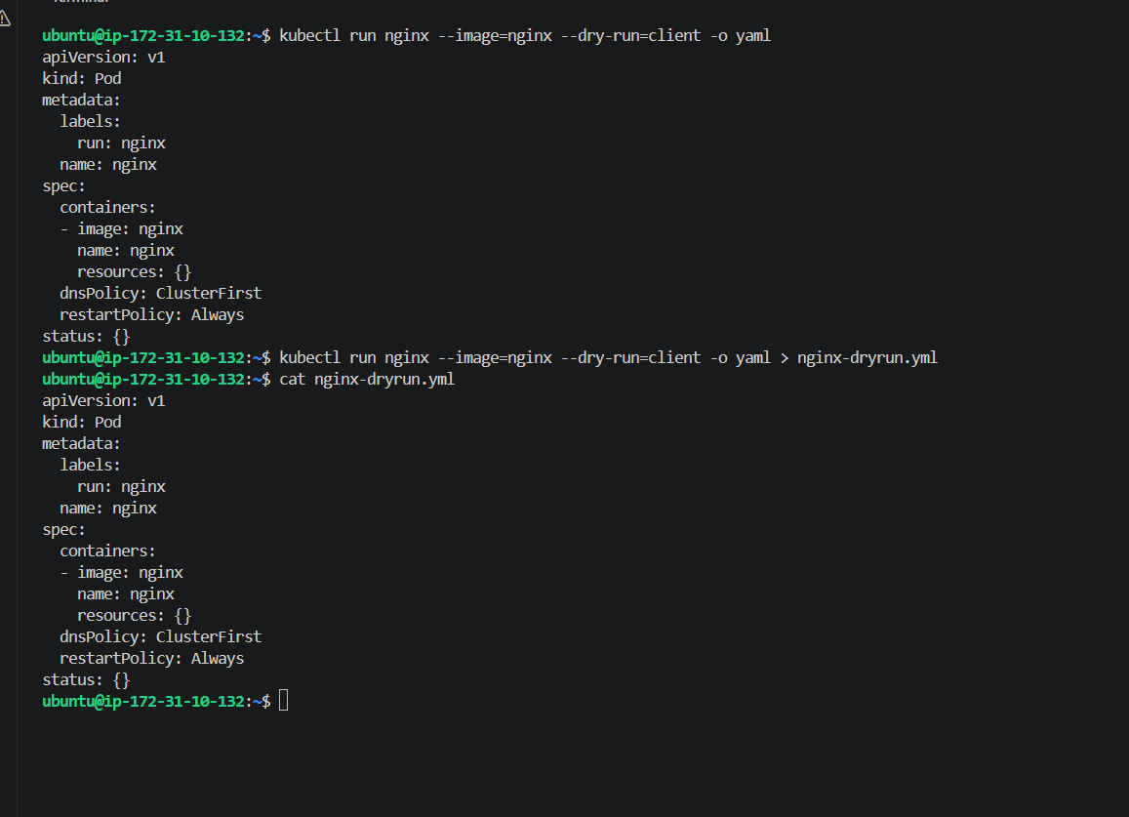
2. Modify the generated YAML
Open it:
nano nginx-dryrun.yml
Replace the complete file with:
apiVersion: v1
kind: Pod
metadata:
name: nginx-dryrun
labels:
app: nginx
environment: test
spec:
containers:
- name: nginx
image: nginx
env:
- name: myname
value: "sabair"
- name: City
value: "Hyderabad"
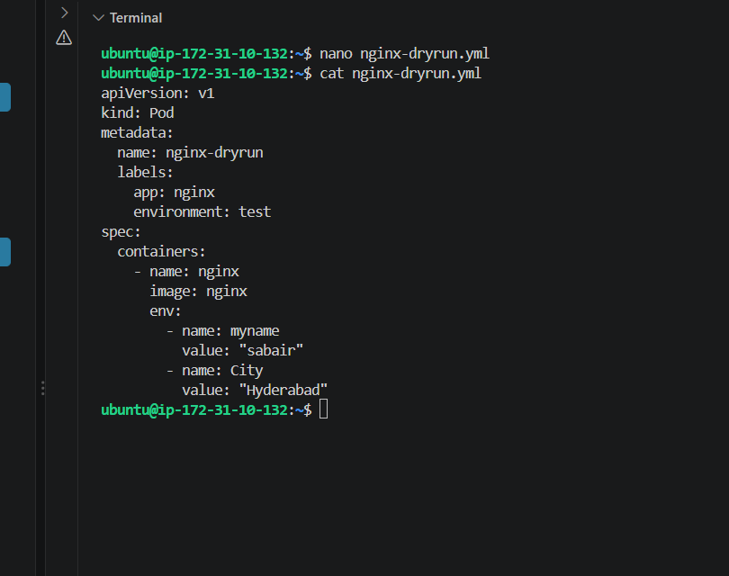
3. Deploy
kubectl apply -f nginx-dryrun.yml
4. Verify
kubectl get pod nginx-dryrun
Expected:
nginx-dryrun 1/1 Running
5. Verify labels
kubectl get pod nginx-dryrun --show-labels
6. Verify environment variables
kubectl exec nginx-dryrun -- env | grep -E 'myname|City'
Expected:
myname=sabair
City=Hyderabad
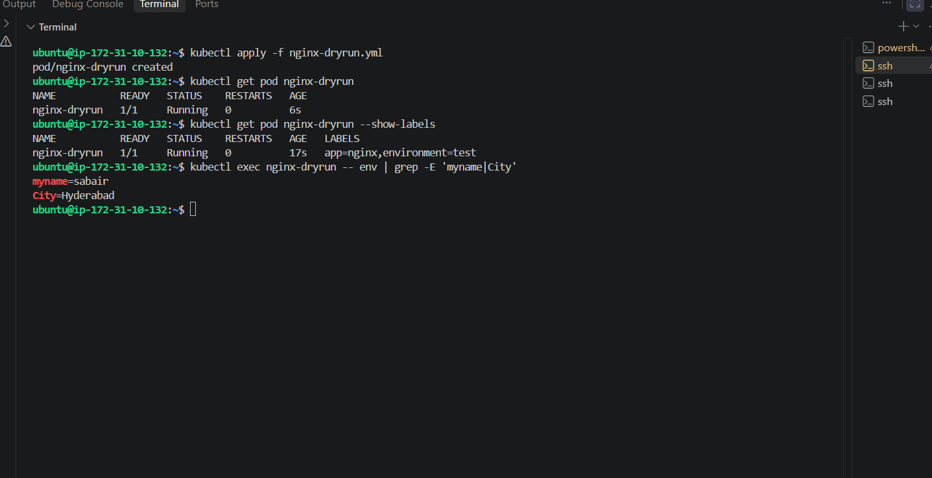
Task 7 — kubectl create vs kubectl apply
We'll demonstrate the difference practically.
1. Create a new YAML
nano create-apply.yml
Use:
apiVersion: v1
kind: Pod
metadata:
name: create-apply-pod
spec:
containers:
- name: nginx
image: nginx:1.27
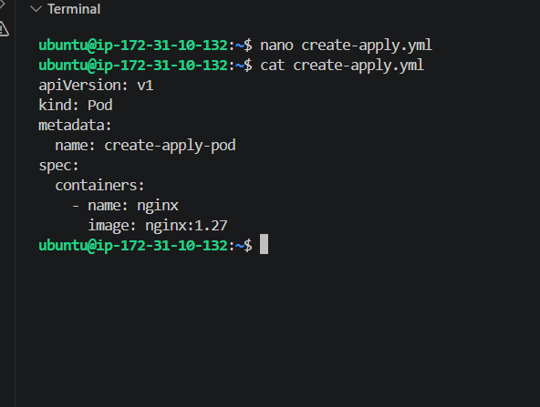
2. Deploy using kubectl create
kubectl create -f create-apply.yml
Expected:
pod/create-apply-pod created
Verify:
kubectl get pod create-apply-pod
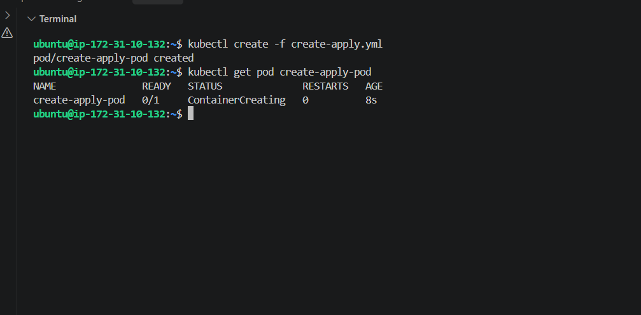
3. Modify the image
Open the file:
nano create-apply.yml
Change only:
image: nginx:1.27
to:
image: nginx:1.28
4. Apply the change
kubectl apply -f create-apply.yml
Then:
kubectl get pod create-apply-pod
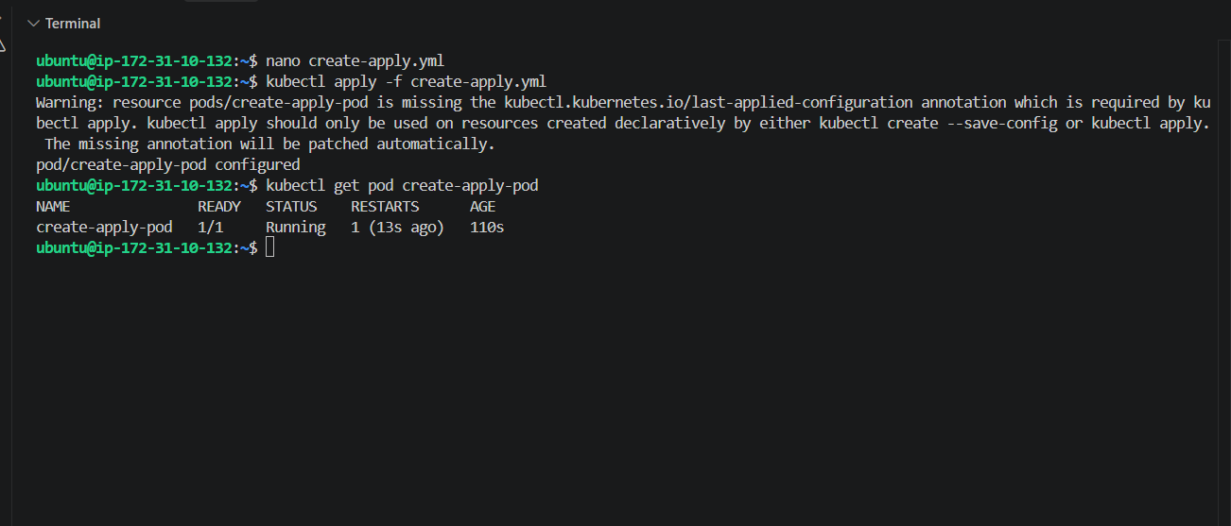
Verify the image
Run:
kubectl get pod create-apply-pod -o jsonpath='{.spec.containers[0].image}'
Expected:
nginx:1.28
Then:
kubectl describe pod create-apply-pod | grep -A 5 "Containers:"
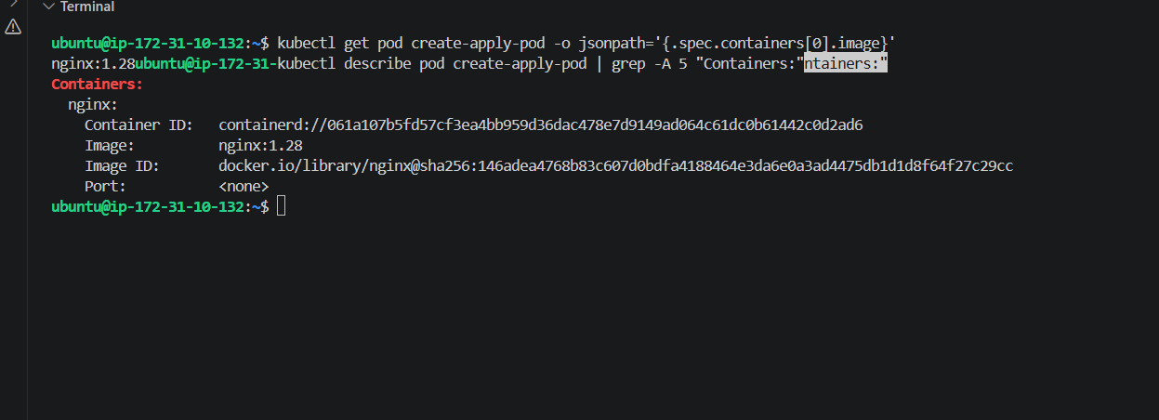
Task 8 — Edit an Existing Pod
Requirement:
Use kubectl edit pod <pod_name> to modify the running Pod's environment variables or image, then verify the change.
We'll use create-apply-pod.
1. Edit the Pod
Run:
kubectl edit pod create-apply-pod
Your editor will open.
Find:
containers:
- image: nginx:1.28
name: nginx
Change the image to:
image: nginx:1.29
Save and exit.
Then verify
kubectl get pod create-apply-pod -o jsonpath='{.spec.containers[0].image}'
Expected:
nginx:1.29
Then:
kubectl get pod create-apply-pod
Wait until:
create-apply-pod 1/1 Running
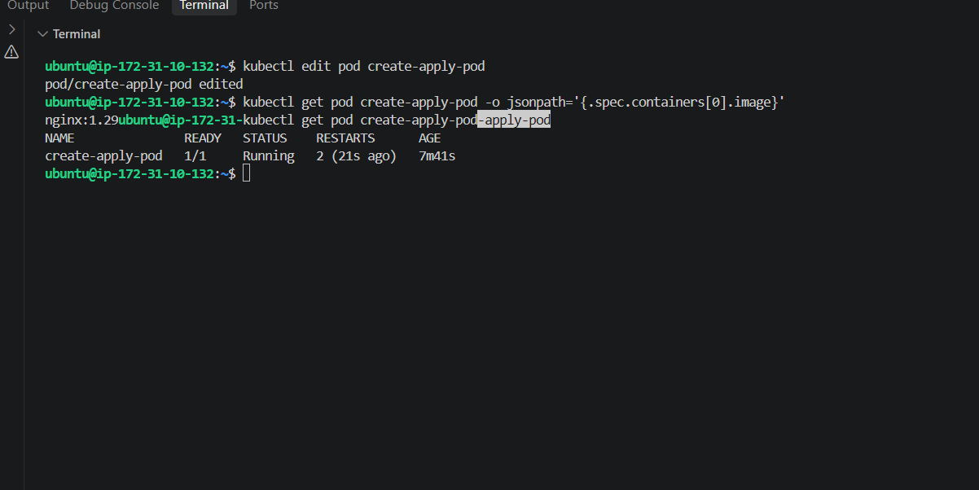
Task 9 — Expose firstpod using a ClusterIP Service
We need to expose firstpod on port 80.
First, check the current firstpod:
kubectl get pod firstpod --show-labels
Our current firstpod has no labels, so we'll add a label through the Service selector by first updating the Pod YAML.
1. Replace firstpod.yml
nano firstpod.yml
Use this complete YAML:
apiVersion: v1
kind: Pod
metadata:
name: firstpod
labels:
app: firstpod
spec:
initContainers:
- name: init-container
image: busybox
command:
- sh
- -c
- "echo Init container started; sleep 30; echo Init container completed"

containers:
- name: nginx1
image: nginx

- name: nginx2
image: nginx
command:
- /bin/sh
args:
- -c
- |
sed -i 's/listen 80;/listen 8080;/' /etc/nginx/conf.d/default.conf
nginx -g 'daemon off;'
Save and exit.
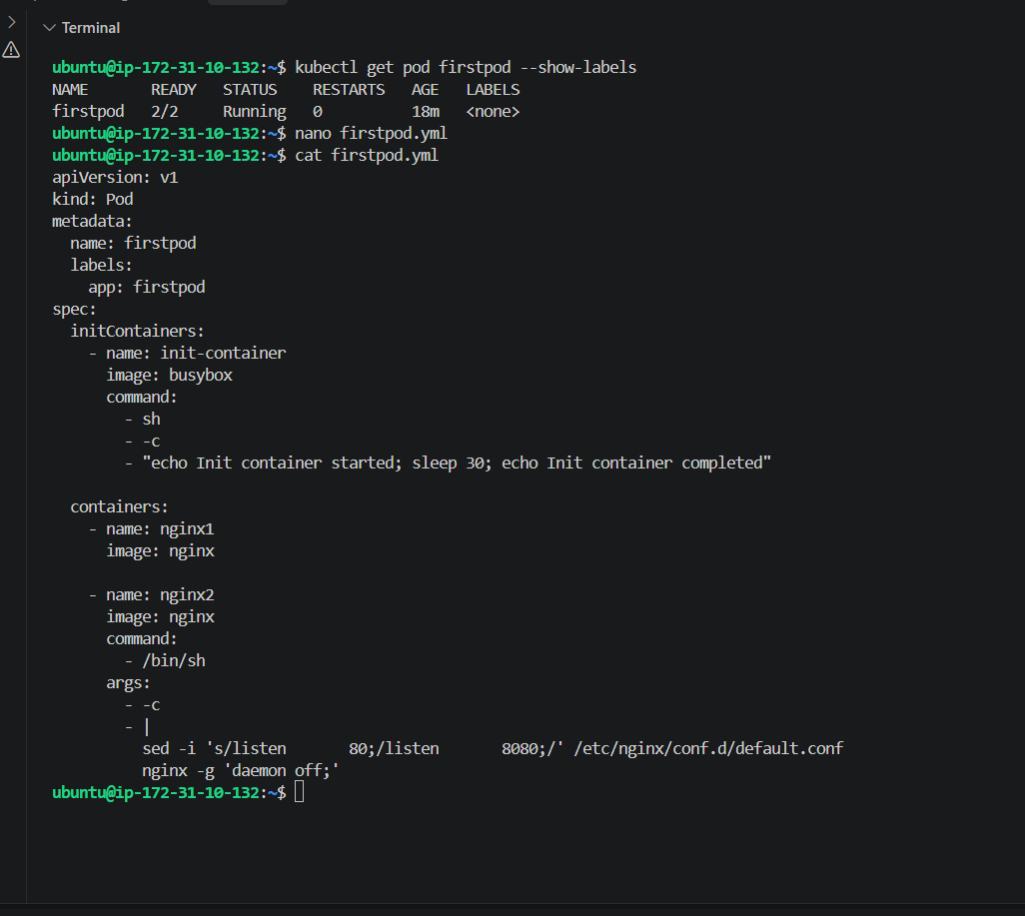
2. Recreate firstpod
kubectl delete pod firstpod
Then:
kubectl apply -f firstpod.yml
Wait until:
kubectl get pod firstpod
shows:
firstpod 2/2 Running
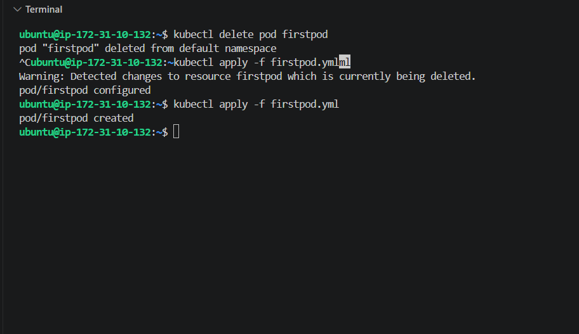
3. Create Service YAML
nano firstpod-service.yml
Use:
apiVersion: v1
kind: Service
metadata:
name: firstpod-service
spec:
type: ClusterIP
selector:
app: firstpod
ports:
- protocol: TCP
port: 80
targetPort: 80
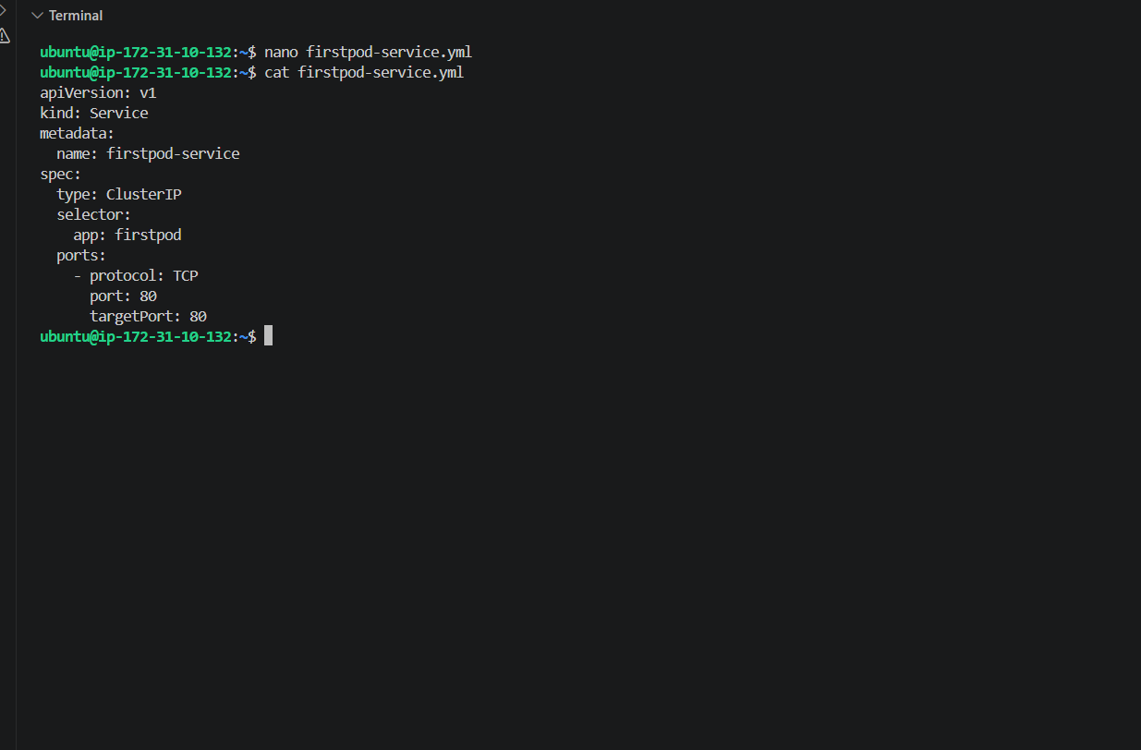
4. Create the Service
kubectl apply -f firstpod-service.yml
5. Verify
kubectl get svc
You should see something like:
NAME TYPE CLUSTER-IP EXTERNAL-IP PORT(S)
firstpod-service ClusterIP 10.96.x.x <none> 80/TCP
Also verify:
kubectl get endpoints firstpod-service
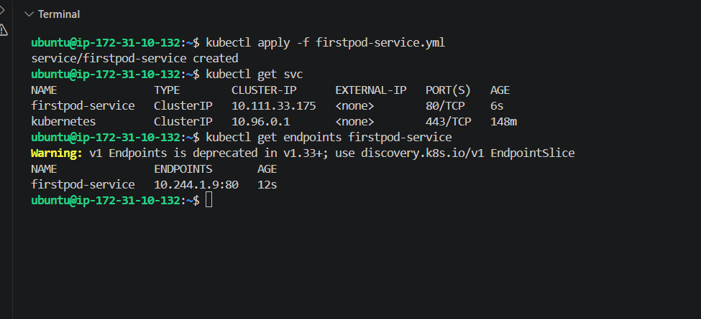
Task 10 — Resource Requests and Limits
Now the last K8s-02 task. 🎯
We need to add CPU and memory requests and limits for both containers.
1. Replace firstpod.yml
nano firstpod.yml
Use this complete YAML:
apiVersion: v1
kind: Pod
metadata:
name: firstpod
labels:
app: firstpod
spec:
initContainers:
- name: init-container
image: busybox
command:
- sh
- -c
- "echo Init container started; sleep 30; echo Init container completed"

containers:
- name: nginx1
image: nginx
resources:
requests:
cpu: "100m"
memory: "128Mi"
limits:
cpu: "200m"
memory: "256Mi"

- name: nginx2
image: nginx
command:
- /bin/sh
args:
- -c
- |
sed -i 's/listen 80;/listen 8080;/' /etc/nginx/conf.d/default.conf
nginx -g 'daemon off;'
resources:
requests:
cpu: "100m"
memory: "128Mi"
limits:
cpu: "200m"
memory: "256Mi"
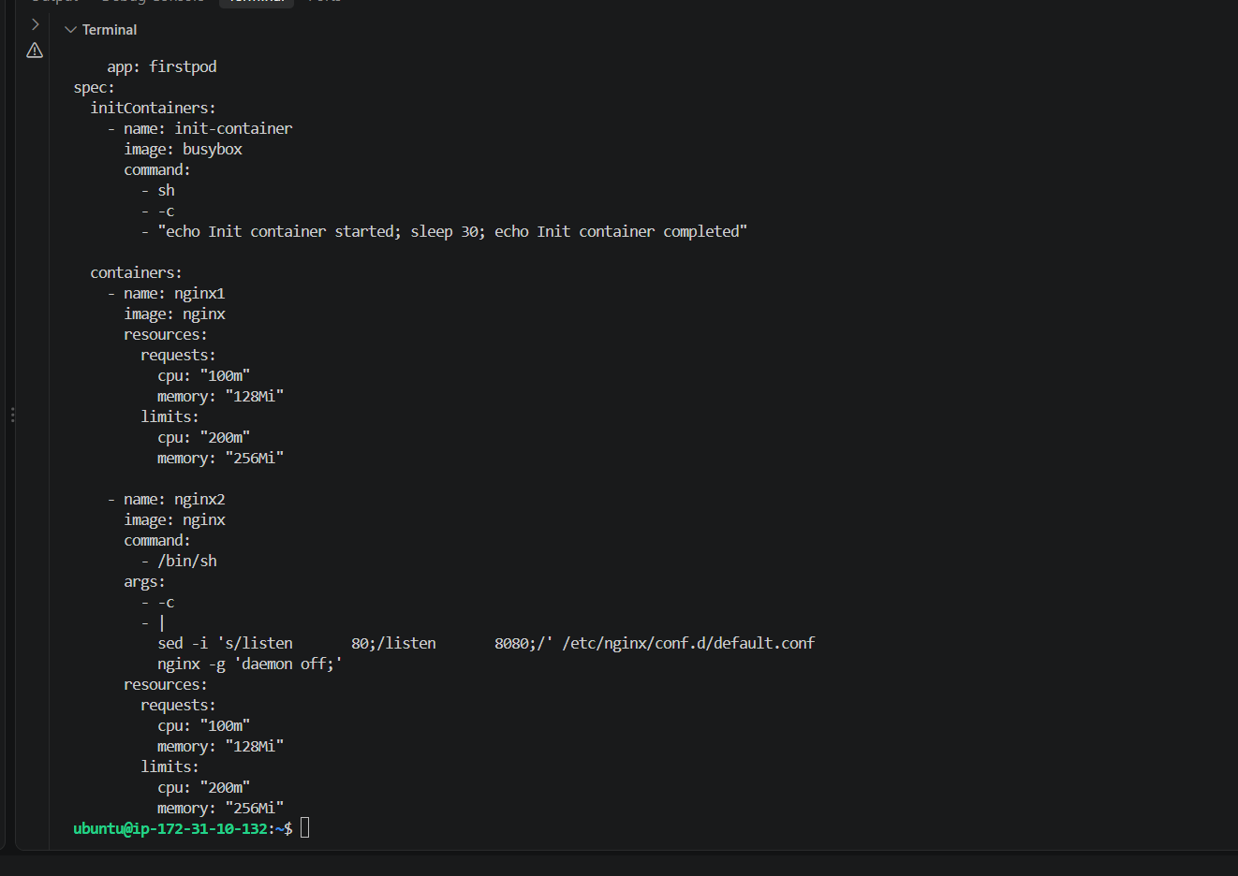
2. Recreate the Pod
Because we're changing the Pod specification:
kubectl delete pod firstpod
Then:
kubectl apply -f firstpod.yml
Wait for the init container to finish:
kubectl get pod firstpod
Eventually:
firstpod 2/2 Running
